Code:

%% Problem 1

myRbgIm = imread('im.png');

myIm = double(im2gray(myRbgIm));

a = 0.4;

N = 3;

g1 = blur(myIm,0.4);

g1 = reduce(g1);

subplot(2,3,1);

imshow(g1);

g2 = blur(g1, 0.4);

g2 = reduce(g2);

subplot(2,3,2);

imshow(g2);

g3 = blur(myIm, 0.4);

g3 = reduce(g3);

subplot(2,3,3);

imshow(g3);

l3 = g3;

l2 = expand(g2) - g1;

l1 = expand(g1) - myIm;

recontruction = l1 + expand(l2) + expand(l3);

imshow(recontruction);

% function

function image_blured = blur(img,a)

x = [.25-.5.*a .25 a .25 .25-.5.*a];

y = [.25-.5.*a; .25; a; .25; .25-.5.*a];

%blur

temp = imfilter(img, x);

image_blured = imfilter(temp, y);

end

function img_reduced = reduce(img)

[NR, NC] = size(img);

img_reduced = zeros(uint8(NR/2), uint8(NC/2));

for r = 1:NR/2

for c = 1:NC/2

r_indices = 2*r-1:2*r;

c_indices = 2*c-1:2*c;

img_reduced(r,c) = mean(mean(img(r_indices, c_indices)));

end

end

end

function img_expanded = expand(img)

[NR, NC] = size(img);

%disp(NR);

%disp(NC);

img_expanded = zeros(2*NR, 2*NC);

img_expanded(1:2:end, 1:2:end) = img;

img_expanded(2:2:end, 2:2:end) = img;

for r = 2:2:2*NR-1

for c = 2:2:2*NC-1

img_expanded(r,c) = (img_expanded(r-1,c) + img_expanded(r+1,c))/2;

end

end

end

Here is what I did for Problem one. I meet some problems here and I spent at least 20 hours on this question but I still can’t solve it. I designed three functions. The first one is blur(img, a) which is used to blur the image. The last two functions is used to resize.

%% Problem 2

walk = imread('walk.bmp');

bg = imread('bg000.bmp');

walk = double(walk);

bg = double(bg);

diff = abs(walk - bg);

threshold = [0.1, 0.5,10,20];

i = 1;

for T = threshold

im = diff > T;

subplot(2,2,i);

imshow(im);

i = i+1;

title("T=" +T);

end

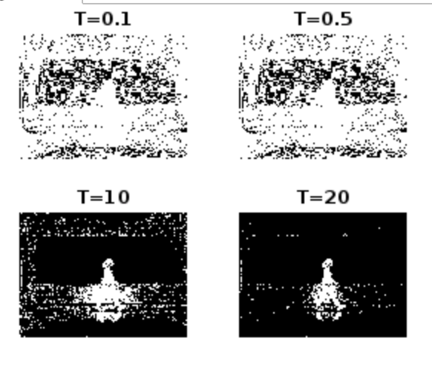

Here is what did for question 2. I set T to 0.1, 0.5, 10, and 20. With a bigger Threshold, the output becomes clearer.

%% Problem 3

for i=1:30

filename = sprintf('bg%03d.bmp', i-1);

bg(:,:,i) = double(imread(filename));

end

walk = imread('walk.bmp');

walk = double(walk);

meanBg = mean(bg, 3);

%calculate the standard deviation

sig = zeros(240,320);

for j=1:30

sig = sig+((bg(:,:,j) - meanBg).^2)/30;

end

sig = sqrt(sig);

sDistance =abs(walk - meanBg)./sig;

threshold = [0.1, 0.5,10,20];

i = 1;

for T = threshold

im = sDistance > T;

subplot(2,2,i);

imshow(im);

i = i+1;

title("T=" +T);

end

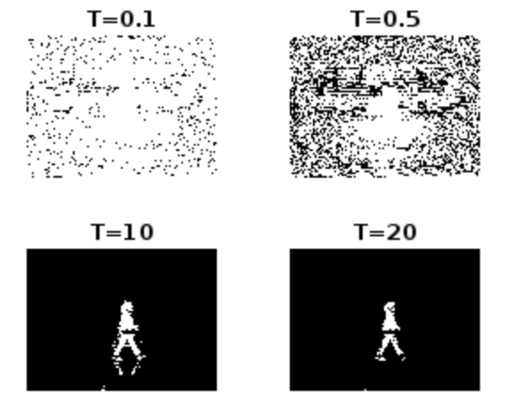

Here is what I did for problem 3. There are fewer noises in the output compared with problem 2.

%% problem 4

T =20;

bsIm = sDistance > T;

d_bsIm = bwmorph(bsIm, 'dilate');

imshow(double(d_bsIm));

imwrite(bsIm, 'bestBinary.jpg');

title("best binary image");

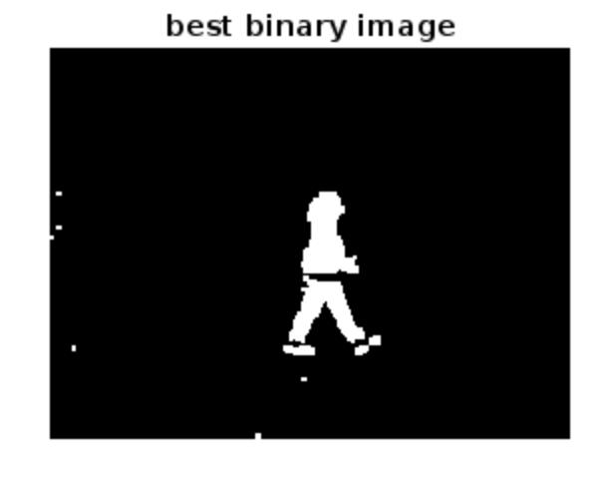

Here is what I did for Problem 4. I dilate my best binary image.

%% problem 5

[L, num] = bwlabel(d_bsIm, 8);

stats = regionprops(L, 'Area');

areas = [stats.Area];

[~, maxIndex] = max(areas);

largest = ismember(L, maxIndex);

imshow(largest);

imwrite(largest, 'largest.jpg');



Here is what I did for problem 5. I perform the connected components algorithm and keep the largest region in L.